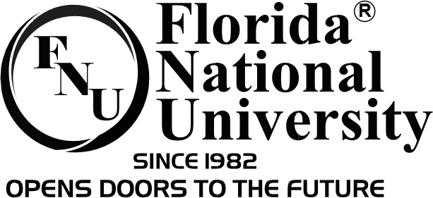

Photo and Video Release Form

I, ________________________________, grant Florida National University the right to take pictures/videos of me in connection with activities and/or events.

I agree that Florida National University may use such pictures/videos of me for any lawful purpose, including for example publicity, illustration, advertising, social media, and web content.

By signing this form I acknowledge that I have read and understand the above. I hereby release Florida National University, its directors, officers, successors, etc. from any and all demands, claims and actions for the use of the pictures, videos, etc.

Signature: ________________________________________________________

Printed Name: ____________________________________________________

Address:____________________________________________________________________________________________________________________________

Date: ____________________________________________________________